* 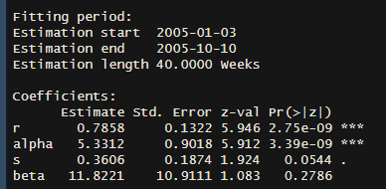The more weeks the more significant alpha
* The shorter time intervals the better overall significance of parameters

PAlive

|  |  |  |  |
| --- | --- | --- | --- |
| Predicted\True | Alive | Not alive | Total |
| Alive | 100 | 20 | 120 |
| Not alive | 80 | 50 | 130 |
| Total | 180 | 70 | 250 |

|  |  |  |  |
| --- | --- | --- | --- |
| Predicted\True | Alive | Not alive | Total |
| Alive | 100 | 20 | 120 |
| Not alive | 80 | 50 | 130 |
| Total | 180 | 70 | 250 |

|  |  |  |  |
| --- | --- | --- | --- |
| Predicted\True | Alive | Not alive | Total |
| Alive | 100 | 20 | 120 |
| Not alive | 80 | 50 | 130 |
| Total | 180 | 70 | 250 |

Ein Bild, das Text, Diagramm, Reihe, Screenshot enthält.
